

SCHOOL *of* BUSINESS AND TECHNOLOGY

Department of Engineering and Aviation Sciences

**Satellite Image Analyzing App to Perform Crop Health Predictions**

**Timothy Riley Jr**

Advisor: Dr. Zhang

May, 5 , 2020

Satellite Image Analyzing App to Perform Crop Health Predictions

By

Timothy Riley Jr

Submitted to the Department of Engineering and Aviation Sciences in partial fulfillment of the requirements for the degree of Bachelor of Science in Engineering at the

UNIVERSITY OF MARYLAND EASTERN SHORE

Date 05/13/2020

The author hereby grants the University of Maryland Eastern Shore permission to reproduce and distribute publicly, paper and or electronic copies of this document in whole or in parts.

Authors Timothy Riley Jr

Signature

Date 05/13/2020

Department of Engineering and Aviation Sciences

Certified by

Special notice for formatting for the whole report:

1. Keep the formatting consistent (learn and apply the MS ‘Styles’ in formatting). Do not change any format but just apply corresponding styles as listed.
2. Do not add any blank rows but use BREAKS, except the end of a table. BREAKS can be found on ‘Page Layout’ → ‘Page Setup’ → ‘Breaks’.
3. Every figure or picture must be mentioned in the text first then can appear. When it is mentioned, use the cross-reference.
4. Every figure or picture in the text must be accompanied with the caption and detailed description.
5. Only third person is allowed (except the Conclusion and Acknowledge sections). Never use ‘we’, ‘our’, ‘you’, etc. anywhere else (use the ‘find’ function of MS Office to double check).
6. Use ‘do not’ other than ‘don’t’, and so forth.
7. You can copy any reference information from anywhere, but anything not from yourself must be refereed and the original information must be included in the Reference section.
8. The reference must be organized with professional software such as ‘Endnote Web’, ‘Mendeley’, etc. Use IEEE reference format.
9. Try Grammarly. It can help in fixing typos and grammar errors.
10. If you get ‘Styles’ messed up, the easiest way is to start over, to open this blank template and copy-paste contents into it.

List of Contents

Table of Contents

List of Contents 4

List of Figures 2

List of Tables 2

Abstract 2

Chapter 1. Introduction 2

Background/Motivation 2

Objective 2

Design Requirements 2

Design Constraints 2

1.1 Design Constraints 2

Design Method (Approach) 2

Standards 2

Chapter 2. Project Description 2

System Description 2

System Diagram 2

System Functions 2

Chapter 3. Implementation Plan 2

Tasks 2

Team Organization 2

Timeline/Milestones/Delivery Plan 2

Chapter 4. Implementation 2

Implementation of Task 1. 2

1. Implementation of Subtask 1.1 2

2. Implementation of Subtask 1.2 2

Implementation of Task 3. 2

4.1 2

4.2 2

3. Implementation of Subtask 3.1 2

4. Implementation of Subtask 3.2 2

5. Implementation of Subtask 3.3 2

Implementation of Task 2. 2

4.1 2

6. Implementation of Subtask 2.1 2

Chapter 5. Project evaluation 2

Chapter 6. Conclusion 2

Acknowledgment 2

Appendix 3

A. Source Code. 3

1. Source Code of producing polygonal boundaries of field sites: 3

2. Source Code of importing and creating map layer of Sentinel-2 image dataset 3

3. Source Code of Clipping image data to field boundary 3

4. Source Code of extracting pixel band values 3

5. Source Code of linked map UI 3

6. Source Code of extracting excel sheet data 3

REFERENCES 3

List of Figures

Figure. 1. Figure 1: Pesticide spraying device 5

Figure. 2. Figure 2: Canola species of cover crop 5

Figure. 3. Figure 3: Earth Engine Application for analyzing Amazonian fires in Bolivia 6

Figure. 4. Figure 4: System Diagram 8

Figure. 5. Figure 5: image taken of a singular field quadrat. 12

Figure. 6. Figure 6: Description of the layout of the web based IDE for Google Earth Engine. 13

Figure. 7. Figure 7: Zoomed in display of two boundaries from the field site data 14

Figure. 8. Figure 8: Representation of the band values corresponding to a random pixel in the Sentinel-2 image collection. 15

Figure. 9. Figure 9: Satellite image clipped to two field site boundaries. 15

Figure. 10. Figure 10: Array of pixel band values from field sites. 16

Figure. 11. Figure 11: Excel spreadsheet of metadata recorded from multiple quadrants of the Bradbury field site 16

Figure. 12. Figure 12: Prompt from Earth Engine code asking for field data name. 17

Figure. 13. Figure 13: Basic UI for location finding functionality 18

Figure. 14. Figure 14: Display of linked map UI 19

Figure. 15. Figure 15: Example of a decision tree flow chart. 21

Figure. 16. Figure 16: Visualization of a random forest regression model 21

List of Tables

Table 1. Project Timeline and Delivery Plan 10

Abstract

By the end of the project, summarize the project into short text and put here (can be waived for Senior Design I). The abstract needs to be more than half page.

1. Introduction

This project will be the development of a web application in Google Earth Engine that performs plant health predictions on satellite images. The web application will implement a trained machine learning algorithm that predicts the biomass and percent of nitrogen from a satellite image of plant life. The algorithms predictions will also be converted into a raster map by the application and presented to the user interactively.

## Background/Motivation

Modern agriculture today operates far differently than that of decades before due to the various advancements in technology like sensors, devices, machines, and information technology. Today’s agriculture routinely uses sophisticated technologies such as robots, temperature and moisture sensors, aerial images, and GPS technology. These advanced devices and precision agriculture and robotic systems allow businesses to be more profitable, efficient, safer, and more environmentally friendly.

With the rise in the application of artificial intelligence technologies in multiple industries globally, it is beginning to make its mark in the agriculture industry as well. Farms produce hundreds of thousands of data points on the ground daily. With the help of AI, farmers can now analyze a variety of things in real time such as weather conditions, temperature, water usage or soil conditions collected from their farm to better inform their decisions. For example, AI technologies help farmers optimize planning to generate more bountiful yields by determining crop choices, the best hybrid seed choices and resource utilization. AI systems are also helping to improve harvest quality and accuracy -- what is known as precision agriculture. Precision agriculture uses AI technology to aid in detecting diseases in plants, pests, and poor plant nutrition on farms. AI sensors can detect and target weeds and then decide which herbicides to apply. This helps to prevent over application of herbicides and excessive toxins that find their way in our food. A visual example of a pesticide spraying robotic device is shown in figure[1]. All approaches to AI in agriculture have the same overarching goal, to quantify factors leading to crop health for the farmers benefit and therefore the consumers benefit.

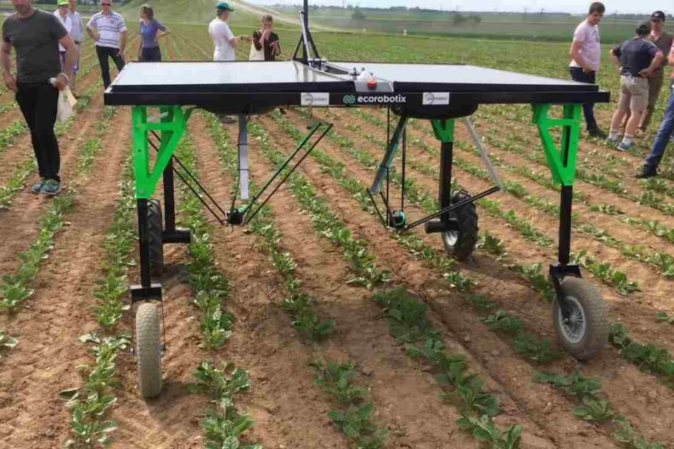

1. Figure : Pesticide spraying device

Plant health can be quantified in different ways like, presence of diseases, crop growth over time, or color. A very common way to determine a crops health is to look at its biomass content and its percentage of nitrogen in the soil.Biomass and nitrogen content are essential factors to the growth and sustainability of plant life. Biomass is the weight of living plant material contained above and below a unit of ground surface area. A greater biomass content translates to more abundant plant life and health. Nitrogen is a key component of chlorophyll and directly affects photosynthesis. Photosynthesis is the process of converting sunlight into energy for growth of the plant. Monitoring and assessing the content of both factors is critical in ensuring the wellbeing of the crop. It is well known by Agriculturists (farmers) that cover crops enhance the quality of crop production. One of the important benefits of cover crops is their impact on soil nitrogen cycling. The cover crops will trap excess nitrogen that would normally runoff, into the soil. The cover crop also produces more nitrogen for the crop it is growing beside for when levels of nitrogen normally decrease during the year. An example of a cover crop is shown in figure [2].

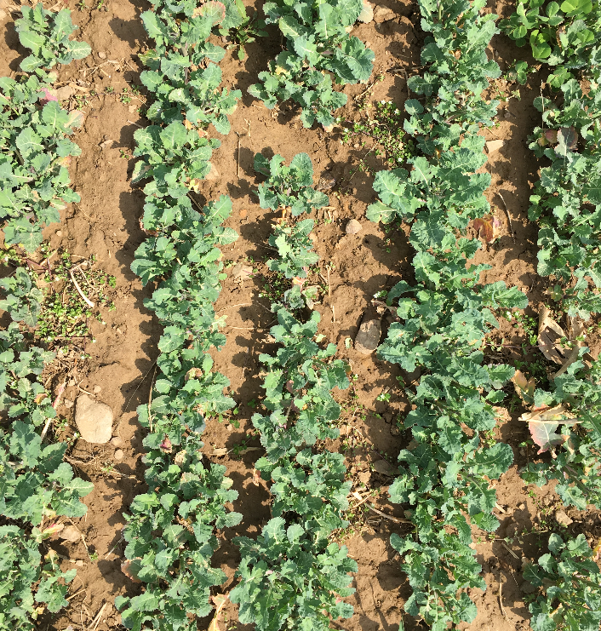

1. Figure : Canola species of cover crop

.Many research projects are underway on this topic of using cover crops to control nitrogen levels by multiple agencies such as the USDA. The Demand for sensing and analyzing the data needed for the topic is very high but difficult to achieve due to the large scale on which farm/ field sites operate. There is data supporting that plant health can be measured from advanced imaging such as near-infrared reflectivity. Research has previously been conducted using a handheld NVDI meter to estimate levels of biomass nitrogen content in different cover crop species (White, Bradley, Finney, Kaye, 2019). Results of this estimation process were generally successful with predicting biomass nitrogen content from multiple species of cover crops and achieving over 75% confidence in predictions. This faucet though doesn't add much scalability or ease of use to the user as they must take the predictions themselves at different spots around their field with the device.

Satellite image processing has become significantly improved and accessible in recent years. This has led to its ideal use in applications that analyze large regions of geographical data. A large part of this movement was caused by the introduction of Google Earth Engine. An example of analyzing an area of land on earth's surface using Earth Engine is shown in Figure [3].

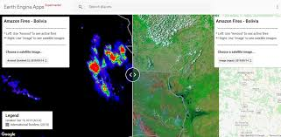

1. Figure : Earth Engine Application for analyzing Amazonian fires in Bolivia

With the use of satellite imaging major areas can be analyzed quickly and efficiently. An entire field can be processed within minutes. This saves the farmer a great deal of time in analyzing their crops and assists in up-keeping the health of the field.

## Objective

To deploy a web application through Google Earth Engines (GEE) API that analyzes satellite images and produces raster mapping of plant health, in the form of biomass content and percent nitrogen predictions.

## Design Requirements

1. Perform regression on pixels to obtain predictions of biomass & nitrogen content with at least 90% accuracy
2. Access satellite images from coordinate inputs.
3. Display results of biomass and nitrogen content as a raster map layer on top in the Earth Engine API
4. Provide an interactive user interface with the Satellite Map

## Design Constraints

## Design Constraints

1. Web application must be written in Google earth engine.
2. Accessible data is determined by images taken by the constellation of Sentinel satellites and field data taken from field sites by the USDA
3. Pixel resolution of sentinel images is accurate down to 10 m by 10 m area.

## Design Method (Approach)

The first step to accomplish design requirements is to analyze and organize the data from satellite images and excel spreadsheets. Organizing consists of assigning coordinates and labels to every element in the dataset. The second step is to write the source code for an Alpha version of the Google Earth Engine app. Which is just a basic script for the base functionality of the application to be built upon. The third step is to preprocess the data into training and validation datasets for Tensorflow. The fourth step is to build and train a machine learning model in Tensorflow with the dataset. The fifth step is to improve model accuracy by analyzing prediction results and modifying the structure of the model then training again to see new results. The sixth step is to add backend integration to the application that combines the prediction algorithm with the satellite image data. The seventh step is to improve the User interface code and workflow of the application.

Achieving proper functionality from the application system can be simplified into ensuring these 5 major technical processes operate correctly and uniformly: Satellite Image Interpretation, Plant health interpretation, Machine Learning Algorithm, Earth Engine User Interface (UI), Earth Engine backend script. Each major process holds multiple tasks leading to a section of script to be written in Javascript. In the end these scripts will be implemented on top of the basic application code to each provide a crucial component to the functionality of the final product.

## Standards

N/A

1. Project Description

In this section, you are going to add more details of 'what' and answer the question 'how'.

## System Description

The system is a Web application accessible via web browser and served through Google’s Cloud Computing services. The backend of the application including its neural network will be written in python and the front end User Interface (UI) will be written in Javascript. The User Interface for the application is accessed through Google Earth Engine website. The User interface will show the most recent imaging from the Sentinel II satellite and will have a prompt asking for a location. Once requested the application will capture an image of that location then utilize a neural network to process the image to predict the Biomass content and nitrogen % of every pixel of that image. That vector data is transferred to raster mapping and presented to the UI for the user to evaluate. Figure 4 shows the system diagram for the flow of the application.

## System Diagram

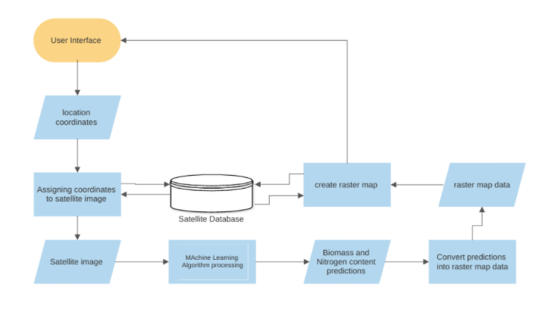

1. Figure : System Diagram

## System Functions

1. When the user goes to the link of the Google Earth Engine app, satellite imaging is shown and can be interacted with to view different areas of the world.
2. Application prompt is displayed on the user interface (UI) asking for location coordinates
3. Application prompts the user to specify the dates of images intended to view
4. When coordinates are given to the prompt the application accesses the Sentinel-II satellite image database and directs the UI to show the corresponding coordinates submitted.
5. ‘run’ button is used to begin prediction processing.
6. Application processes the satellite images of the location displayed then utilizes the machine learning algorithm embedded in the code to produce predictions on plant health.
   1. Application breaks down the image pixel by pixel and performs prediction analysis on each pixel to obtain values of biomass and percent nitrogen.
7. The Application takes those prediction values and converts them into mappable raster data
8. The raster map data is associated with the pixel locations of the original image and a raster map layer is produced on the output map
9. The UI is now updated and prompting the raster map data and legend where the areas of good plant health and bad plant health were predicted to be.
10. The UI also shows options to save/download dataset images of the original satellite image and the raster map image.
11. Implementation Plan

## Tasks

* Task 1. Preprocessing the Dataset
  + Subtask 1. isolate necessary information from satellite
  + Subtask 2. isolate vital information from field site data
  + Subtask 3. Correlate quadrat data to pixel location in satellite images
  + Subtask 4. Build Dataset input pipeline
* Task 2. Produce Machine Learning Network
  + Subtask 1. Build Network structure & begin initial training.
  + Subtask 2. Collect results, revise and retrain the network.
* Task 3. Develop Alpha-Application in GEE
  + Subtask 1. Build UI that accesses Sentinel - II satellite images
  + Subtask 2. Add coordinate location functionality
  + Subtask 3. Add image capture functionality
* Task 4. Backend Development
  + Subtask 1. Preprocess the captured image for compatibility to network input
  + Subtask 2. Integrate the trained neural net model into the GEE API
  + Subtask 3. Write code to associate prediction output values with satellite image pixel locations
* Task 5. Frontend
  + Subtask 1. Convert Biomass and Nitrogen % predictions to Raster Map data values
  + Subtask 2. Write code to Draw Raster map over satellite image
  + Subtask 3. Build User Interface for interaction with the Raster map
* Task 6. Testing and Refinement
  + Subtask 1. Test the operability of the application and its ease of use
  + Subtask 2. Refine the Apps use and workflow

## Team Organization

Timothy Riley is the sole team member responsible for all tasks and subtasks in completing this project.

## Timeline/Milestones/Delivery Plan

1. Project Timeline and Delivery Plan

|  |  |  |  |
| --- | --- | --- | --- |
| Time | Task | Comments | Responsibility |
| week 1 | Start task 1.1 | read and extract satellite images of field locations |  |
| week 2 | Start task 1.2 | organize biomass and percentage nitrogen from field level data |  |
| week 3 | Start 3.1 | correlate field level data to pixel locations in satellite image |  |
| week 4 | Start 3.2 |  |  |
| week 5 | Complete 1.3 | Build Dataset input pipeline |  |
| week 6 | Complete 2.1 | Build ML algorithm structure & begin training |  |
| week 7 | Start 2.2 | Collect results from initial training then start revision process [5 weeks needed] |  |
| week 8 | Continue 2.2 | revise structure or parameters of the algorithm |  |
| week 9 | Continue 2.2 | initiate training again and repeat process |  |
| week 10 | Continue 2.2 |  |  |
| week 11 | Continue 2.2 | achieved accuracy of 90% is ideal |  |
| week 12 | Start 5.3  Complete 3.1 | write Google Earth Engine app that can access the Sentinel II satellite database interactively |  |
| week 13 | Start 3.2, 3.3 | add functionality to capture image of a location when coordinates are given |  |
| week 14 | Complete 3.2, 3.3 |  |  |
| week 15 | Start 4.1, 4.3, 4.2 | write the code that breaks down the captured image into a pixel array |  |
| week 16 | Finish 4.1, 4.3 | Associate each pixel with a value representing its location |  |
| week 17 | Continue 4.2 | integrate Machine Learning algorithm into the App code (takes pixel as input and outputs prediction values) |  |
| week 18 | Finish 4.2  start 5.1, 5.2 | Convert prediction values into mappable raster data |  |
| week 19 | continue 5.2 | use pixel location values and raster mp data to draw raster map over the captured satellite image |  |
| week 20 | Continue 5.3 | add more user interface features to view and download the raster map image and data results from the algorithm |  |
| week 21 | Finish 5.3 | perform final user testing then deploy application to Google Earth Engine platform, finalize system and documentation |  |
| week 22 | Task 6 | Analyze application performance and conduct final redesigns |  |

1. Implementation

The pages that follow will highlight the processes completed, tools used, and skills gained for proper execution of the tasks at hand defined in this project's scope. The major services and tools used and referred to in the task implementations as as follows:

* Google Earth Engine: a cloud-based platform for planetary-scale environmental data analysis.
* Google Collaboratory: Colab is a free Jupyter notebook environment that runs entirely in the cloud.
* Tensorflow: a Python-friendly open source library for numerical computation that makes machine learning faster and easier
* Python: an interpreted, object-oriented, high-level programming language with dynamic semantics.
* Javascript: a scripting or programming language that allows you to implement complex features on web pages.

Completion of the Earth Engine plant health prediction app is dependent upon 5 major technical areas working together; the satellite image processing interpretation, the field level data processing interpretation, the machine learning algorithm, the Earth Engine application User Interface (UI) and the Earth Engine javascript back end code. Work on the first 4 areas is being progressed separately and will be added to the 5th area systematically.

.

## Implementation of Task 1.

Task 1 is vital to the training of the machine learning model because it provides the algorithm with a clear and informative dataset for the model to learn from.There are two parts to the dataset used for training, the satellite images and the plant health metrics (quantifying Biomass content and percentage of nitrogen). The dataset information was obtained from USDA operatives conducting research on quantifying cover crop abundance and other metrics in various fields. The data was sent to me having this initial structure:

Plant health metric data:

5 field sites

3 treatments per site

8 quadrats per treatment

-data sampled twice for each quadrat

-each quadrat is 0.5 m by 0.5 m

- data sampled is of biomass content and % nitrogen taken from soil

An image of the area a quadrat represents can be seen in Figure 5 below.

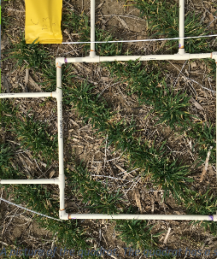

1. Figure 5: image taken of a singular field quadrat.

Satellite imagery data:

5 field sites

7 field geometric outlines

*pixels present in each geometric outline is to be determined*

The data is taken from multiple field sites in Maryland. The satellite images will be analyzed in Google Earth Engines API which has access to the Sentinel-2 surface reflectance image database. The Sentinel-2 satellite is a wide-swath, high-resolution, multi-spectral imaging mission. This satellite monitors vegetation, soil and water cover, as well as observation of inland waterways and coastal areas.

### Implementation of Subtask 1.1

The open source coding platform, Google Earth Engine allows for free extensive use and manipulation of satellite imagery from petabytes of satellite image datasets which are all accessible from their remote databases. Access to the multitude of satellite imagery is available through use of the Earth Engine API. An API is an Application programming interface consisting of a set of tools and protocols used for building software applications. The Earth Engine online code editor is a web based Integrated Development environment (IDE) that utilizes the Javascript API to design and publish applications. A description of the multiple elements within the Earth Engine online IDE can be seen in Figure 6. Reading and understanding the operation of the Earth Engine IDE was critical in manipulating the satellite image data properly.

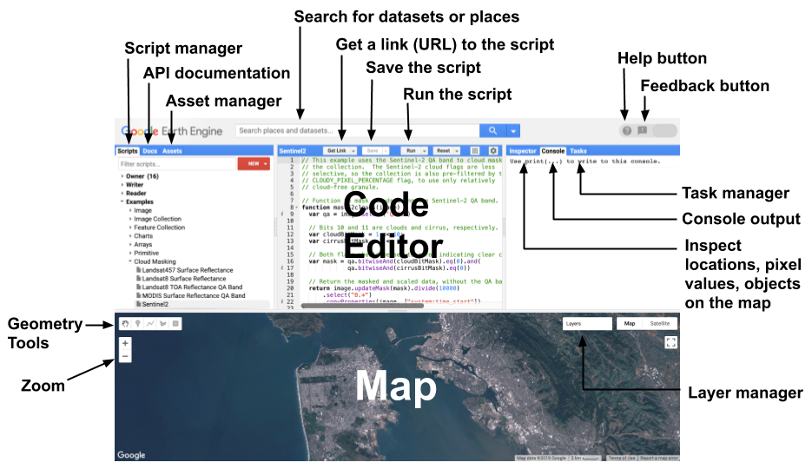

1. Figure : Description of the layout of the web based IDE for Google Earth Engine.

Figure 6 displays the Earth Engine web IDE. The figure labels the base features and layout of the code editor. The API for the online code editor is in Javascript programming language. The obtained dataset for the satellite imagery is in the form of field boundary shapefiles which hold location coordinates for the various sites. The boundary shapefiles can be uploaded and interpreted by the code editor as a feature collection. There are two major forms of data within Earth Engine, the first is feature data and the second is image data.

The feature collection created from the shapefiles held the boundary coordinates of 7 polygons representing the location and area of 7 fields from 5 research sites ( some sites have multiple bounded areas). In order to view the satellite images specific to multiple field sites, a file of assets that hold polygons corresponding to the field site coordinates was uploaded to the Earth Engine console as the feature collection. Then the feature collection was converted into a map layer displaying the polygonal boundaries of the 7 sites on the map. Code for this process can be viewed in **section A1** of the appendix.

The result produced is zoomed in on the Kennyville site in the map of figure 7.

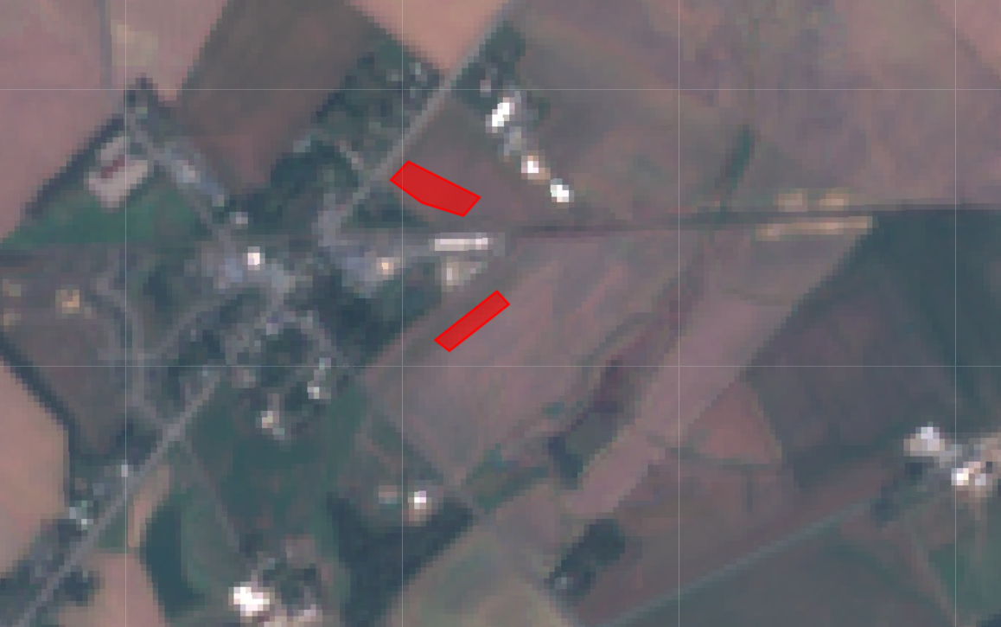

1. Figure : Zoomed in display of two boundaries from the field site data

The red polygons represent the geometry of the field sites where the data for the biomass and percentage of nitrogen was taken from quadrats on those fields. Data in Earth Engine is represented in two main ways, features or images. A collection of feature data was used to draw polygons of the field site locations as a layer in the map. Images in Earth Engine are a stack of Georeferenced bands each with their own mask projection and resolution. the images are represented in arrays of pixels that each hold the band values for the location the pixel represents. The Sentinel-2 surface reflectance database consists of 16 band images. Each band records reflectance at a different wavelength and resolution. That value is then recorded and assigned to the pixel’s coordinates it is belonging to in the Sentinel-2 imaging dataset. Shown in figure 8 is an example of the band values for a random pixel manually inspected in the Earth Engine code editor (in both bar graph and list format):

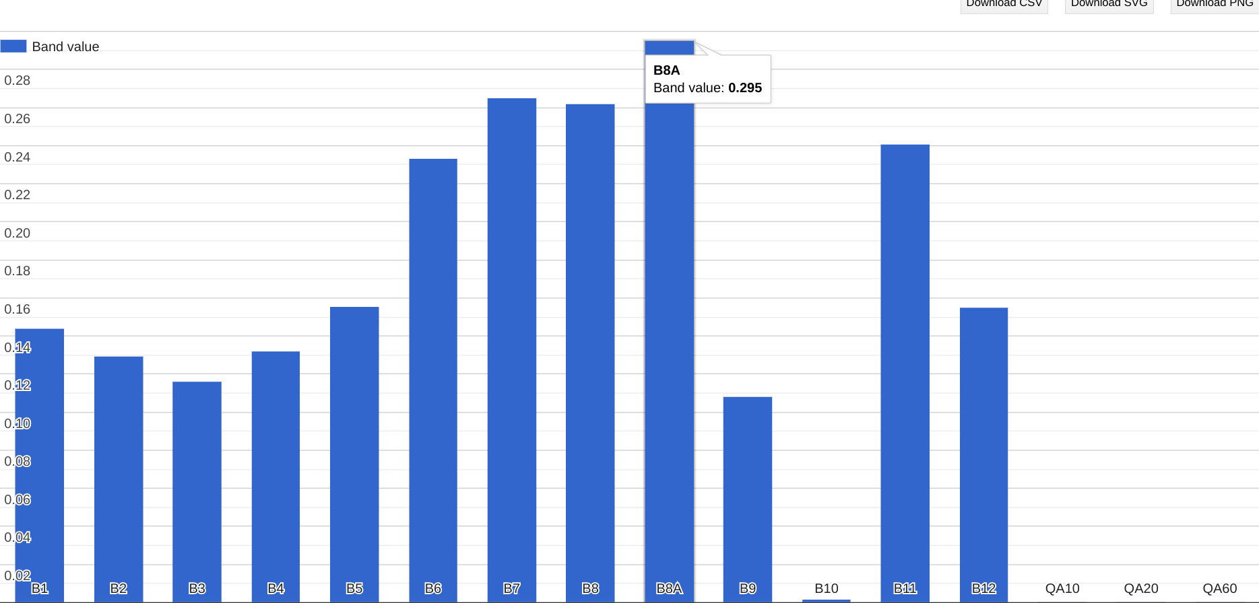 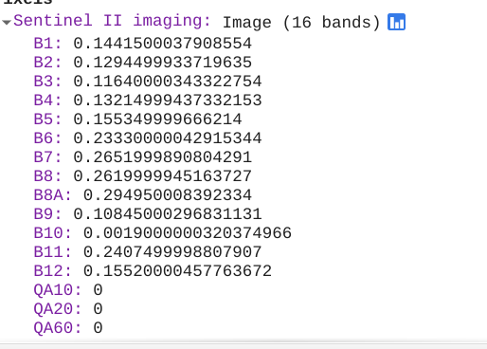

1. Figure : Representation of the band values corresponding to a random pixel in the Sentinel-2 image collection.

The objective of Subtask 1.1 is to accurately quantify the band values of the pixels within the 7 field site boundaries and have them correlate with the pixels specific geographic coordinates. To accomplish this the Satellite imaging data had to be cut to provide values only within the boundaries of the field site polygons. The function, ‘clipToCollection’ was useful in producing new map image bands only within the field site boundaries. The source code for this process can be seen in **section A3**  of the Appendix. The map output is shown in figure 9.

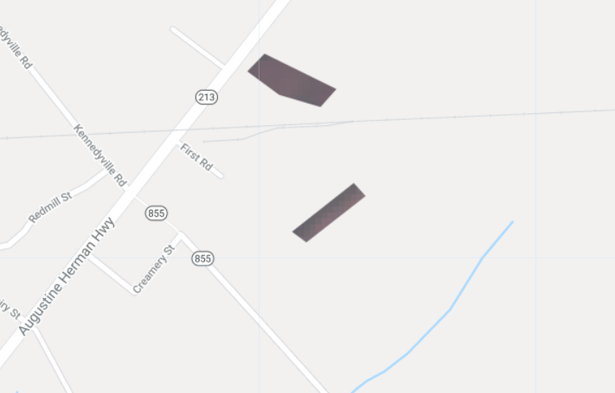

1. Figure : Satellite image clipped to two field site boundaries.

Next the band value metadata of the visible pixels had to be extracted and associated with appropriate location coordinates. The code for extracting pixel data from images in a boundary can be viewed in **section A4**  of the Appendix. The result from the code is an object with arrays of elements each corresponding to a pixels band value as shown in figure 10.

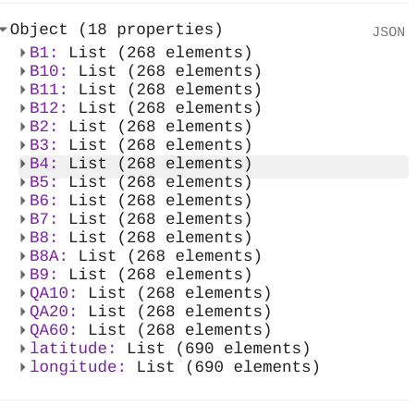

1. Figure : Array of pixel band values from field sites.

The final step is ensuring the coordinates of the pixels match with the band values which will take further investigation in the API to complete.

### Implementation of Subtask 1.2

The second half of the data needed for training a machine learning model is the label data or in this case the values of the biomass and % of nitrogen taken at ground level at the specified field sites. The original data was obtained from the field in the form of quadrats as shown in figure 5. The quadrats dimensions are 1m by 1m. The metadata from the quadrats were recorded into excel files and organized like in the sample figure 11.

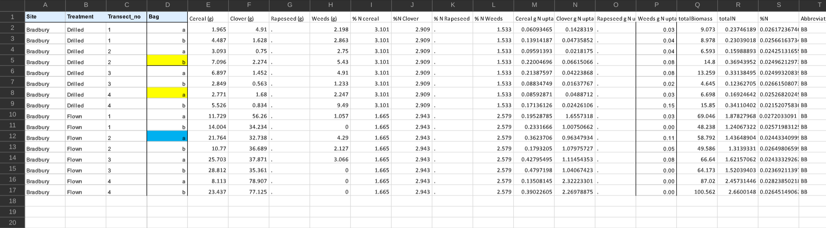

1. Figure : Excel spreadsheet of metadata recorded from multiple quadrants of the Bradbury field site

Figure 11 shows that there were many values obtained from the analyzed quadrats but most of which were focused on seeding rates of the different cover crop species. The main pieces of data vital to this task are the ‘totalBiomass’ , ‘totalN’ , and ‘%N’. Data in excel format can be extracted and interpreted many ways but an efficient tool discovered was the **openpyxl**  library which manipulated excel data in python. This was ideal when trying to use this data with a tensorflow model. The issue that arose in this task was that the quadrat data wasnt scalable enough to correlate to the much larger satellite image. The sentinel-2 images obtain band data down to 10m x 10m pixels which still allows for a large room of misinterpretation of field data. The researchers at USDA are currently in the process of upscaling this field level data to correlate and will be completed within a couple months.

## Implementation of Task 3.

Task 3 is the beginning of writing the code for the app functionality. The app will be written and published within the Earth Engine Javascript API. The most basic functionality of the application are the objectives of task 3, which will be the prompts from the app to the user. First asking for a location coordinate and to use that input to display imaging from the Sentinel-2 surface reflectance database of the location. Then asking for confirmation to use the location displayed to be captured and analyzed to produce plant health predictions.



### Implementation of Subtask 3.1

The earth engine javascript API comes equipped with libraries of functions that perform native Javascript actions as well as functions to analyze, interpret and process geospatial raster and vector data. To accomplish the objective of task 3.1 (initiating the applications user interface) the native Javascript libraries were at play along with a specialized library built towards providing App style interaction (ee.ui). The original satellite map of the code editor is actually a default output of the ui.() library and when the functions are called upon to perform further interface related actions they are printed on top of the map area of the code editor. To begin the task of connecting the user to the application an action for the script to ask the user for an input was developed by using the prompt function. When used in the code editor the result is shown in Figure 12

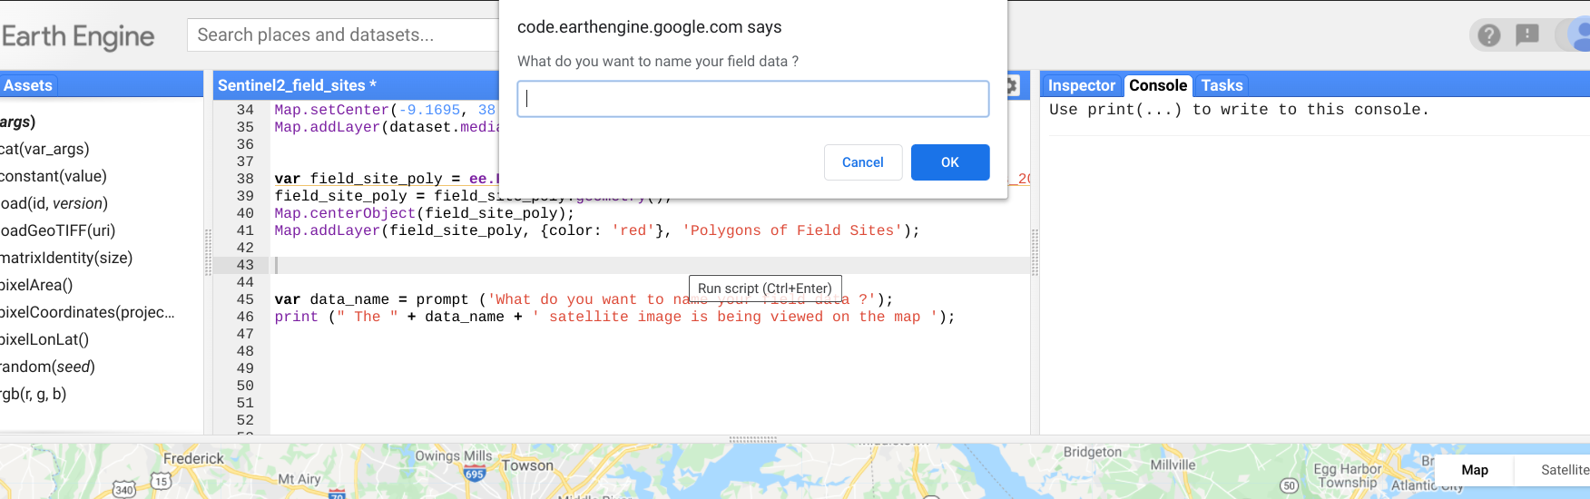

1. Figure : Prompt from Earth Engine code asking for field data name.

This is just the basis for the prompts that the application will display to the user. Other prompts produced will be for coordinates, algorithm activation, and raster map exporting. The Sentinel-2 satellite database was written to be imported to the code of the application ( source code for this process shown in **section A2**  of the Appendix) . Once the prompted question is answered the program displays the satellite data onto the map. This represents basic operation of the application, prompt and visual response. Although it was found that the ui function library within the API was useful for adding another element of cohesion and interaction between user and program.

To begin implementation of the ui interface in the application script, it was necessary to understand the language and syntax of javascript. Three vital concepts for production of a capable ui program were ‘variables’, ‘functions’ and ‘objects’ in javascript. Functions in Javascript are blocks of code designed to perform particular tasks and is executed when something calls upon it. A variable in Javascript is a container for data values. A function is defined with the ‘function’ keyword then is followed by a name for the function then followed by parentheses () the names within the parenthesis represent the parameters to be used within the function. the code to be executed as part of the function is contained within curly brackets{}. An object in Javascript is similar to a variable but objects contain many values which give the object multiple attributes. An object is defined in the following syntax:

var object1 = { name1:value1 , name2:value2, name 3:value3}

### Implementation of Subtask 3.2

The first functionality of the application would be for the user to specify the location that they would like to be shown on the map. When provided with longitude and latitude coordinates the script uses the MapCenter function to show the field location in the console map. Figure 13 displays the prompt from the Earth Engine spript to the user asking for longitude coordinates. After thr longitude is inputted to the scrip the user will be prompted to enter the latitude coordinates.

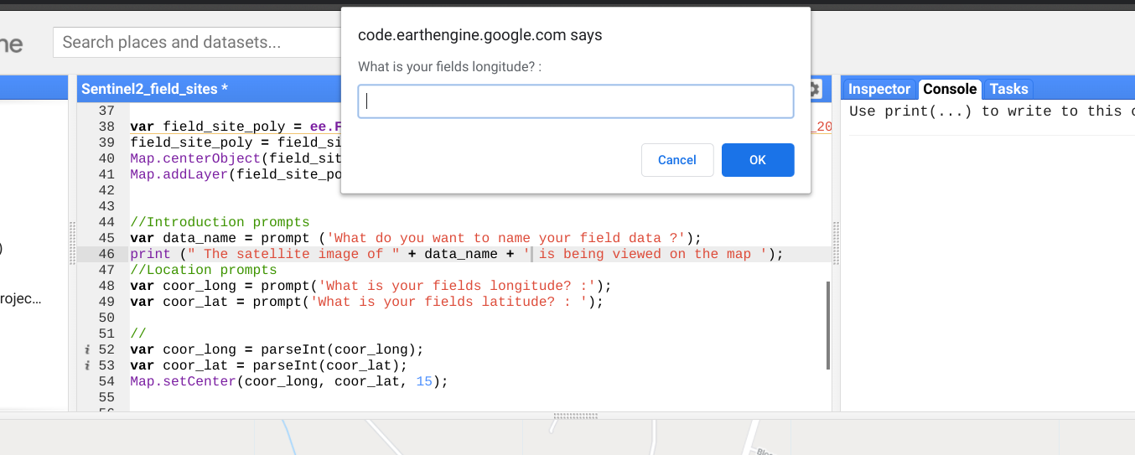

1. Figure : Basic UI for location finding functionality

The next step was to add this functionality as a UI widget where latitude and longitude have seperate input areas but perform as before and set the map to center on that coordinate.

### Implementation of Subtask 3.3

The original design feature objective for subtask 3.3 was for the application to capture the satellite image of a certain location with given coordinates and geometry of area. But new ui libraries in Earth Engine allow for a more interactive experience so a different approach for task 3.3 was underway using the link map functionality. Instead of doing predictions/processing on still images and outputting resulting processed images, the application will be designed to show the normal RGB image of a field on one side of the map and processed image on the other. This allows a more interactive experience and comparison for the user.

The basic functionality for this design began with just displaying linked maps of displaying different bands from the satellite. This was done by adding a ui layer to the basic code editor map then attaching multiple panels to it with their own visualization parameter. Which displays the specified bands of the satellite image in that panel as shown in Figure 14. Each band has a wavelength and resolution that highlights different features of satellite imaging for example Band B4, B3, B2 show normal RGB imaging but B8, B11, B4 highlight differences between land and water.

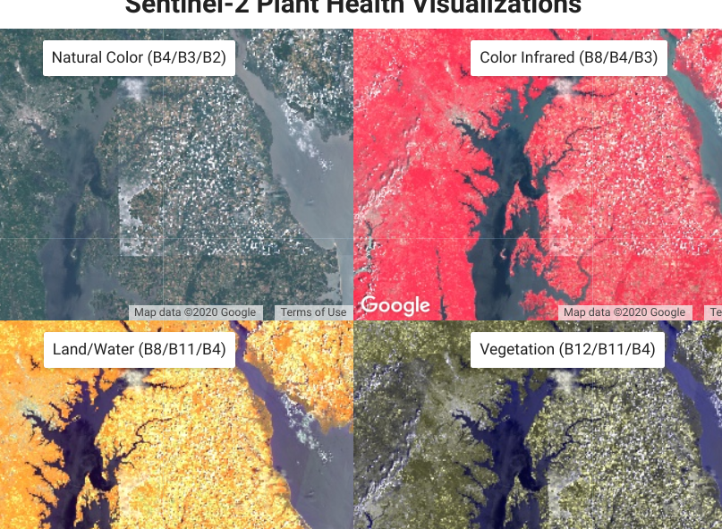

1. Figure : Display of linked map UI

The maps are also linked to each other in that when the RGB image is panned/moved with the mouse, the other maps also move with it still displaying their band imaging. The source code for producing this linked map ui is displayed in **section A5.**

## Implementation of Task 2.

Task 2 is the next major step in achieving the design requirements for the application, The Machine Learning Algorithm. Machine learning is an application of artificial intelligence allowing computational systems ability to learn and improve from experiences. A machine learning algorithm is the blueprint that's produced after a system is trained to process data. A system is trained to learn from datasets through models or structures that present the data to the system in various ways allowing the system to find and record patterns in the data to apply to a new set. There are multiple frameworks that employ machine learning and deep learning processes making the training process simpler on the data scientist. One of which is Tensorflow, an open source library for high level numerical computing. In this design Tensorflow will be used to produce a machine learning algorithm able to process and predict biomass content and % of nitrogen present in satellite pixels.



### Implementation of Subtask 2.1

The First step in the general process of structuring any machine learning algorithm or deep learning network is defining the problem that needs to be solved. This way the important factors for development are defined like what the output should be and what the success metric should look like. In this case the problem is estimating metrics of biomass content and percentage of nitrogen on a very large scale. The desired success metric for the model should be 90%. The next step is identifying what the specific output of the model would look like, for example most models are for either classification or regression. Classification predictive modeling is the task of approximating a mapping function (f) from input variables (X) to discrete output variables (y) [diff between class and reg- reference here]. This basically means that the objective of the model is to analyze its input and use its trained weights to create a mapping function that is then used to assign a class or category to that input. Regression predictive modeling is the task of approximating a mapping function (f) from input variables (X) to a continuous output variable (y).[reffff] This means that the model will utilize its mapping function to quantize the input it is given or a numerical output. A classification output would be something along the lines of color like ‘blue’ or ‘red’ (a label). A regression output would be something like a cost estimation (a quantity). In the case of this design problem, this would need the implementation of a regression model to use inputs from satellite metadata to produce numeric predictions of biomass content and percentage of nitrogen.

The next process in developing a model would be to collect, prepare and preprocess the data. Done properly the quantity and quality of the data will determine how accurate the model can become. A ill preprocessed dataset will hinder the maximum accuracy the model can achieve no matter the qualities of the models structure. The machine Learning model training is dependent upon obtaining the accurate feature(x) and label (y) inputs of a dataset to produce a viable outcome. In the case of this design, the feature (x) input is the satellite pixel metadata/ band values and the label (y) input would be the biomass and % of nitrogen recorded at that pixel. Progress in training the model is halted by the current inaccuracy of the (y) dataset/ field level data. This factor will be solved with the updated and detailed field level data to come from the USDA soon.

This did not restrict development of the model's structure however. Machine learning and Deep learning are the two major subsets of artificial intelligence and each are used to solve ideal objectives. Machine learning is

associated with producing algorithms that allow systems to learn how to make decisions or predictions without being explicitly programmed. Deep learning is a subset of Machine Learning whereas it uses machine learning concepts and constructing algorithmic patterns similar to that of the human brain. The result are neural networks that can vary in layers and size but achieve high level understanding from complex data.

The USDA has previously worked on a similar design of a machine learning model that predicts biomass and percentage of nitrogen from hyperspectral drone images. The model algorithm achieved around 83% accuracy and the architecture of the algorithm was permitted to be altered for this design. The proposed Machine Learning algorithm will be a random forest regression model. This is a supervised learning algorithm that randomly creates and merges multiple decision trees into one forest.

Decision trees are a supervised learning method used for both classification and regression tasks. A decision tree is a flow-chart-like structure, where each internal (non-leaf) node denotes a test on an attribute, each branch represents the outcome of a test, and each leaf (or terminal) node holds a class label or estimation. Figure 15 shows a visualization example of a simple decision tree model.

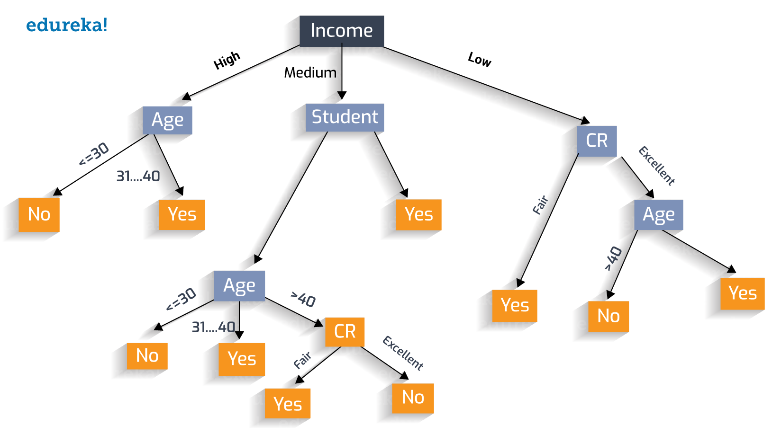

1. Figure : Example of a decision tree flow chart.

Random forest regression is an ensemble tree-based learning algorithm.

Ensemble learning means strategically combining multiple models to accomplish a certain intelligence task.

It aggregates the votes from different decision trees to decide the final class of the test object. Regression refers to presenting a numeric output/prediction. Figure 16 shows a conceptual visualization of a Random decision forest model.

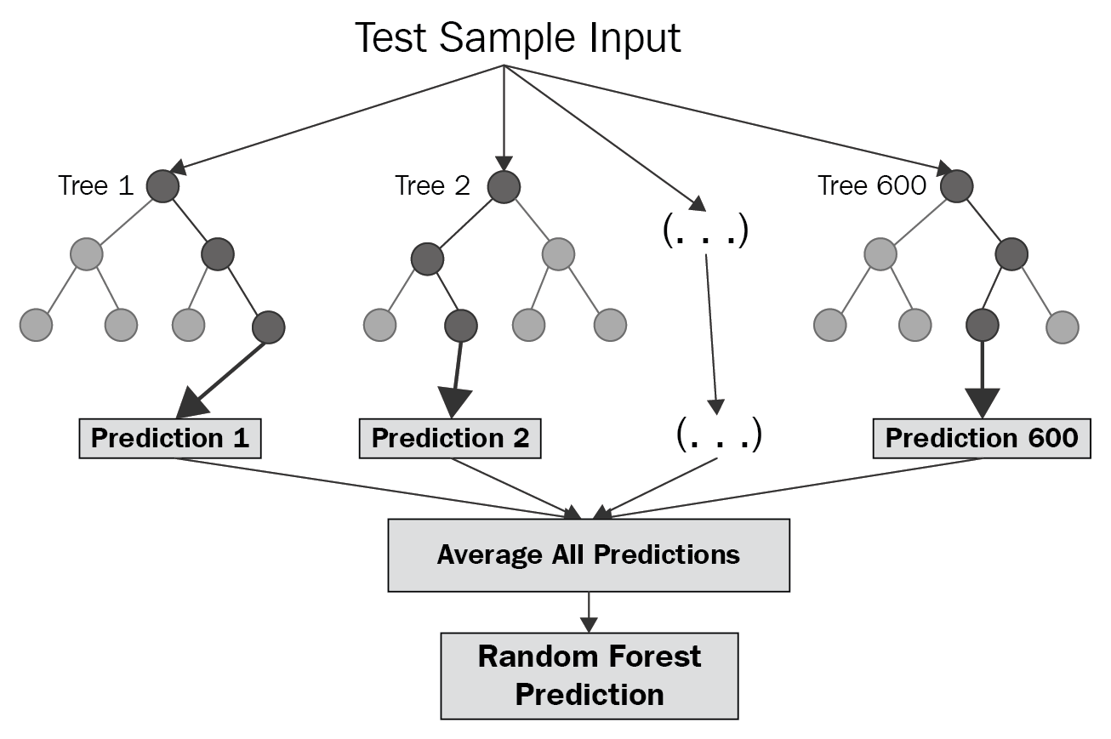

1. Figure : Visualization of a random forest regression model

The first objective of the model design will be to employ a random forest regression model similar to that used by the USDA to predict on the satellite data. The model inputs will be quantized features from the 12 band values extracted at each pixel in the satellite image. The model's outputs will be the average of biomass content and percentage of nitrogen predicted from the multiple decision trees. The structure of this regression model will be a tree ensemble method like that used by the USDA. tf.estimator is an API from the tensorflow library that will be used to train a gradient boosting model using decision trees. The model will first construct 300 trees, each split 12 times for each numerical band value and trained on around 200 indices representing each pixel from the satellite images. Once initial training results are obtained the model structure/parameters will be tweaked to achieve best results possible. If those results do not show to surpass 90% accuracy the focus will shift to producing a deep learning neural network model. This will provide a means for the application to achieve a higher level understanding from the dataset, provided that there is enough training data.

1. Project evaluation

In this chapter, please evaluate the performance of the solution completed in the project with the considerations of public health, safety, and welfare, as well as global, cultural, social, environmental, and economic factors. And please consider improvement suggestion for the future on the aspect.

1. Public health
2. Safety
3. Welfare
4. Global factor
5. Cultural factor
6. Social factor
7. Environmental factor
8. Economic factor
9. Conclusion

By the end of the project, conclude the project and your learning experience.

Please make sure you include the overall evaluation of the project and the **future plan** about how the project can be improved.

* Project summary

…

* Learning and practice experience

…

* Future plan (how to improve)

…

Acknowledgment

Additional assistance in working through this design project was provided by Ph. D. candidate in Geography, Yanan Xin and Dr. Paul Adler from the United States Department of Agriculture.

Appendix

You can put reference info here, including i) specs of components used in the system, ii) source code (must be here but not in the body text), iii) CAD figures, etc.

1. Source Code.

### Source Code of producing polygonal boundaries of field sites:

var field_site = ee.FeatureCollection('users/rileytim413/cover_crop_five_sites_2018');

var field_site_poly = field_site.geometry();

Map.centerObject(field_site_poly);

Map.addLayer(field_site_poly, {color: 'red'}, 'Polygons of Field Sites');

### Source Code of importing and creating map layer of Sentinel-2 image dataset

* Function to mask clouds using the Sentinel-2 QA band

* @param {ee.Image} image Sentinel-2 image

* @return {ee.Image} cloud masked Sentinel-2 image

*/

function maskS2clouds(image) {

var qa = image.select('QA60');

// Bits 10 and 11 are clouds and cirrus, respectively.

var cloudBitMask = 1 << 10;

var cirrusBitMask = 1 << 11;

// Both flags should be set to zero, indicating clear conditions.

var mask = qa.bitwiseAnd(cloudBitMask).eq(0)

.and(qa.bitwiseAnd(cirrusBitMask).eq(0));

return image.updateMask(mask).divide(10000);

}

// Map the function over one year of data and take the median.

// Load Sentinel-2 TOA reflectance data.

var dataset = ee.ImageCollection('COPERNICUS/S2')

.filterDate('2018-01-01', '2018-06-30')

// Pre-filter to get less cloudy granules.

.filter(ee.Filter.lt('CLOUDY_PIXEL_PERCENTAGE', 20))

.map(maskS2clouds);

var rgbVis = {

min: 0.0,

max: 0.3,

bands: ['B4', 'B3', 'B2'],

};

Map.setCenter(-9.1695, 38.6917, 12);

Map.addLayer(dataset.median(), rgbVis, 'Sentinel II imaging');

### Source Code of Clipping image data to field boundary

var bandVis1 = {

min: 0.0,

max: 0.5,

bands: ['B6'],

};

//importing field site boundary features

var field_site = ee.FeatureCollection('users/rileytim413/cover_crop_five_sites_2018');

var field_site_poly = field_site.geometry();

Map.centerObject(field_site_poly);

Map.addLayer(field_site_poly, {color: 'red'}, 'Polygons of Field Sites');

//creating site image clipping to field boundaries

var site_img = ee.Image(dataset.median()).clipToCollection(field_site);

//Map.centerObject();

Map.addLayer(site_img, bandVis1, 'field site images ');

### Source Code of extracting pixel band values

var image = ee.Image(images.filterDate('2018-01-01', '2018-06-30').filterBounds(field_site).first().divide(10000))

Map.addLayer(image, {bands:['B4','B3','B2'], min:0, max:0.3}, 'image')

Map.centerObject(field_site_poly);

Map.addLayer(field_site_poly, {color: 'red'}, 'Polygons of Field Sites');

// values

// get pixel values within region using a given scale

var coords = ee.Image.pixelLonLat()

var values = image

.addBands(coords)

.reduceRegion(ee.Reducer.toList(), field_site, map.scale)

print(values)

### Source Code of linked map UI

// Each map has a name and some visualization parameters.

var MAP_PARAMS = {

'Normal Imaging (B4/B3/B2)': ['B4', 'B3', 'B2'],

'Land/Water (B8/B11/B4)': ['B8', 'B11', 'B4'],

'Color Infrared (B8/B4/B3)': ['B8', 'B4', 'B3'],

'Vegetation (B12/B11/B4)': ['B12', 'B12', 'B4']

};

// Shared visualization parameters for the images.

function getVisualization(bands) {

return {gamma: 1.3, min: 0, max: 0.3, bands: bands};

}

/*

* Configure maps, link them in a grid

*/

// Create a map for each visualization option.

var maps = [];

Object.keys(MAP_PARAMS).forEach(function(name) {

var map = ui.Map();

map.add(ui.Label(name));

map.addLayer(dataset, getVisualization(MAP_PARAMS[name]), name);

map.setControlVisibility(false);

maps.push(map);

});

var linker = ui.Map.Linker(maps);

// Enable zooming on the top-left map.

maps[0].setControlVisibility({zoomControl: true});

// Show the scale

maps[3].setControlVisibility({scaleControl: true});

// Create a grid of maps.

var mapGrid = ui.Panel(

[

ui.Panel([maps[0], maps[1]], null, {stretch: 'both'}),

ui.Panel([maps[2], maps[3]], null, {stretch: 'both'})

],

ui.Panel.Layout.Flow('horizontal'), {stretch: 'both'});

// All maps will align themselves to this parent map.

maps[0].centerObject(table);

// Create title.

var title = ui.Label('Sentinel-2 Plant Health Visualizations', {

stretch: 'horizontal',

textAlign: 'center',

fontWeight: 'bold',

fontSize: '24px'

});

// Add the maps and title to the ui.root.

ui.root.widgets().reset([title, mapGrid]);

ui.root.setLayout(ui.Panel.Layout.Flow('vertical'));

### Source Code of extracting excel sheet data

pip install openpyxl

import openpyxl

from openpyxl import load_workbook

%cd /content/

%ls

field_exel = load_workbook(filename= 'Spring_NBiomass_sample (1).xlsx')

sheet = field_exel.active

plant_health = sheet['Q1':'S9']

for c1, c2, c3 in plant_health:

print("{0:8} {1:8}".format(c1.value, c2.value,c3.value))

REFERENCES

[1] Charles M. White, B. B. (2019). Predicting Cover Crop Nitrogen Content. *Agricultural & Environmental Research letters*, 1-4 .

[2] eudereka. (2019, November 26). *Data Science Introduction*. Retrieved from Eudereka: https://www.edureka.co/blog/decision-trees/

[3] Google. (2019, 09 14). *Developer guide*. Retrieved from Google Earth Engine : https://developers.google.com/earth-engine

[4] Google. (2020, March 04). *Introduction to Tensorflow*. Retrieved from Tensorflow: https://www.tensorflow.org/learn

[5] Kladivko, E. (2016). *Cover Crops for Soil Nitrogen.* Agronomy Department, Purdue University.

[6] M.J. Roberts, S. L. (1985). MEASUREMENT OF PLANT BIOMASS AND NET PRIMARY PRODUCTION. In *Techniwues in Bioproductivity and Photosynthesis* (pp. 1-19).

[7] United States Department of Agriculture. (2020, March 20). *Agriculture Technology*. Retrieved from United States Department of Agriculture National Institute of Food and Agriculture: https://nifa.usda.gov/topic/agriculture-technology

[8] W3 Schools. (2020, April 13). *Javascript*. Retrieved from w3schools.com: https://www.w3schools.com/js/js_objects.asp

[9] Walch, K. (2019, July 5). *How is AI Transforming Agriculture*. Retrieved from Forbes.com: https://www.forbes.com/sites/cognitiveworld/2019/07/05/how-ai-is-transforming-agriculture/#4203edd24ad1